https://lh6.googleusercontent.com/_cCVYVgWtl69X8eXz17wd3XvMbeqUypa6Hx1jknNTzgkl3NlhOkV0alax9mRliSj23s-UUaQz5NGFEAUgKi7yc-63yADb1CrTA7cYwDLTuoII5fB9X0BGLxmM8THF8tSvH6sYwdH



**Design Document for**

**Anturions**

06.10.2015

**───**

Yu-Ching Ho

Muthar Chaudhry

David Smith

**Game Overview**

What is the game?

Humans have landed on Mars and to survive and colonise their centre, they need to connect to a water source. Humans discover and build a relationship with Mars inhabitants - the Anturions. The Anturions are able to dig in Mars surface and create a network of tunnels and bridges in order to direct water to the centre.

Why create this game?

There’s an opening in the market for colonisation games and since the colonisation of Mars is likely to happen in the future, people will be intrigued by “Mars”.

What do I control?

Anturions which affects the relationship with the Anturion Queen and humans.

How many characters do I control?

Can be up to 10, 20 Anturions.

What is the main focus?

To get the water source connected with the human centre.

What’s different?

It’s a unique puzzle game which takes a different approach on the standard puzzle games which are in the market at the moment.

Storyboard and Cut scenes

...

**Gameplay**

Directing the Anturions to build tunnels and bridges to connect a water source.

The efficiency, no. of Anturions used and time? Taken will be calculated and scores will be given out to players. The score will then correspond with an amount of reputation points (RP). The RP can then be used to purchase in-store items and chapters and players will have the option to buy RP with real money as well.

**The Game World**

Overview

Set on Mars. Connect water source to human centre. Overcome obstacles and dangers in environment.

World Features

Each level will present different and new dangers and difficulties which the player will have to overcome.

The Physical World

Overview

Set on different locations on Mars. Anturions will be able to dig into most terrain. Can upgrade Anturions for specific terrain.

Key Locations

Different environments in Mars for each chapter. E.g. Lava, ice, sandy, forested locations.

Objects

Water source, artifacts/collectables, human centre, obstacles, and dangers in environment.

Weather

Can be aesthetic and or may affect some gameplay elements (e.g. being too windy, lava storm, acid ray, radiation, lava geysers), but it’s not a core feature of the game.

Time

Each level will track the player's’ time taken to allocate the score. Some levels will have time-based obstacles.

Rendering System

Overview

Simple sprites with no extra patterns to colours simple. No 3D.

2D/3D Rendering

2D models and gameplay.

Camera

Side-scrolling camera which you’re able to pan the camera back and forth.

Game Engine

Overview

GameMaker, GameSalad, App Game Kit, Unity

Pros and cons for each of them

Cost of each - like getting rid of watermark logo, production cost

Water

Simple physics in the water so the water source will travel appropriately.

Collision Detection

For Anturions - obstacles, water, tunnels, bridges

**The World Layout**

Overview

Varies from chapter to chapter. The world will be built around the puzzles and obstacles. In later chapters, the world may interact with gameplay elements e.g. volcanoes, ice worlds, etc.

World Layout Detail

Simple enjoyable designs based around the puzzles and gameplay. Geometric designs which the player will know what it will represent.

**Game Characters**

Overview

Human civilisation, Anturion Queen, Anturions workers. Humans and Queen will interact to create a storyline after the puzzle is solved; you only control Anturions workers

Creating a Character

Humans and Queen - simple sprite models. Names, voices and some personality may be included. The Anturions workers will have cute cartoony voices when they follow your controls.

Anturion Inspirations

The manga, Terra Formars - Cockroaches which have mutated.

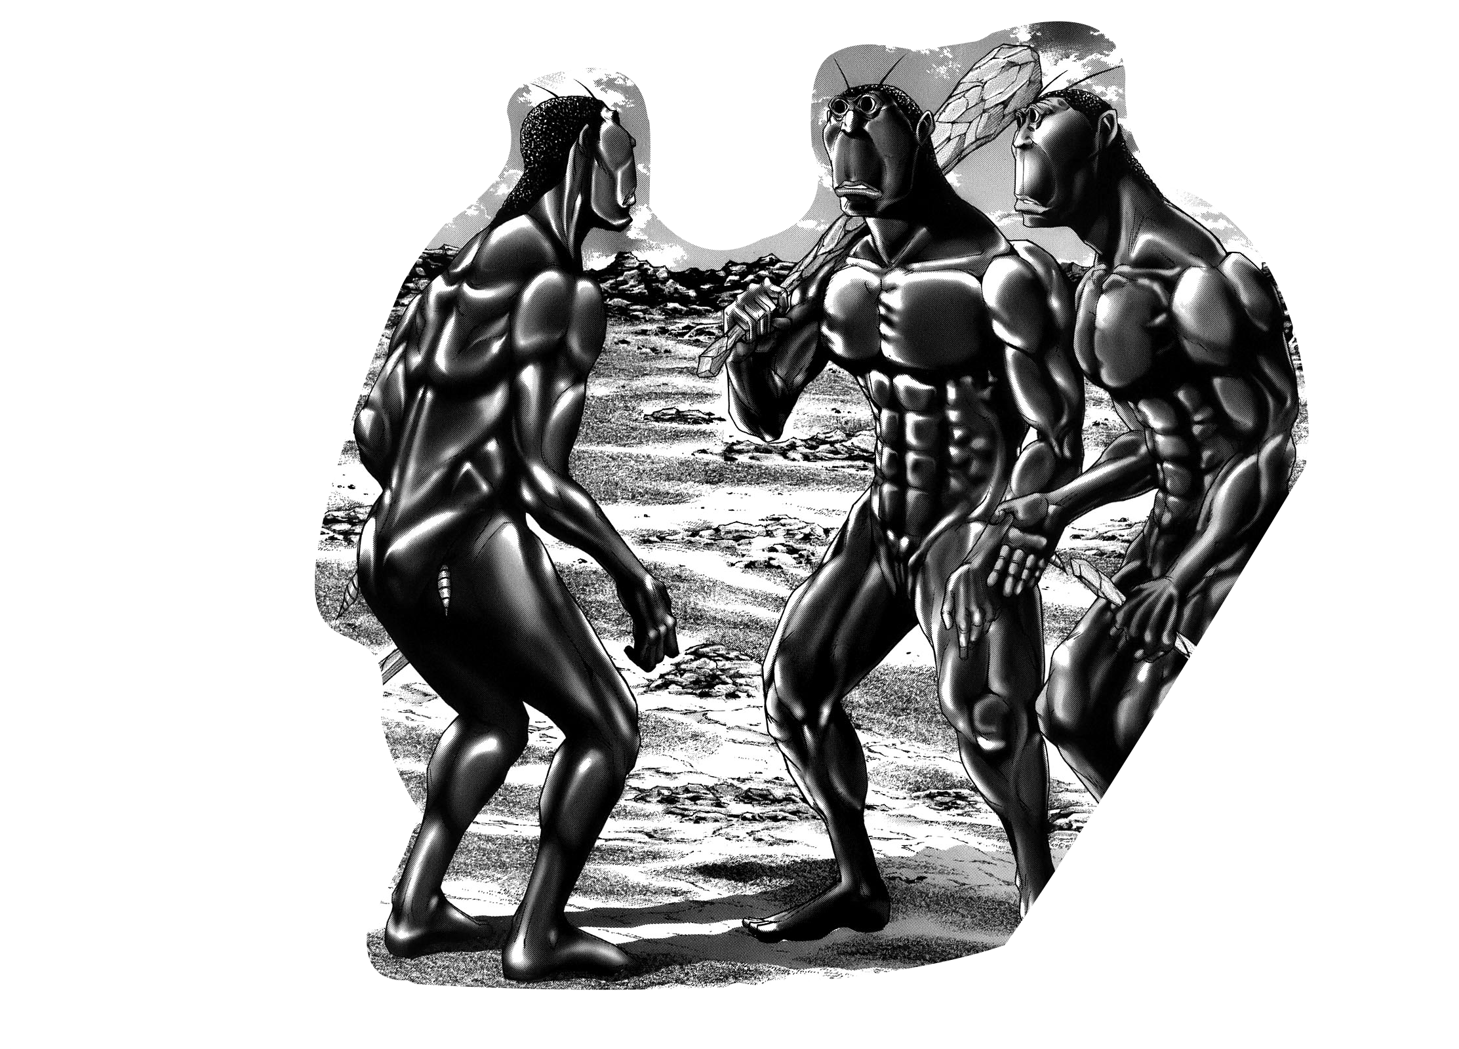

HR Giger

Anturion Concept Art

...

Dangers

Environment obstacles which can block or eat - like plants - Anturions. Later in DLC, the environment can interact with the gameplay.

Dangers Concept Art

…

Dangers Inspirations

...

**User Interface**

Overview

Touch-screen control bar/box along the bottom of the screen; and will also show upgrades of each Anturions when clicked to control.

At the top of the screen, will show stats - e.g. score, time, Anturions left, Anturions alive, and anything else relevant for that particular level.

When upgrading Anturions, screen will show up like image below as an example.

<http://www.gamepilot.ru/upload/Games/nexusae0_Screenshot_2013-10-28-13-04-56.png>

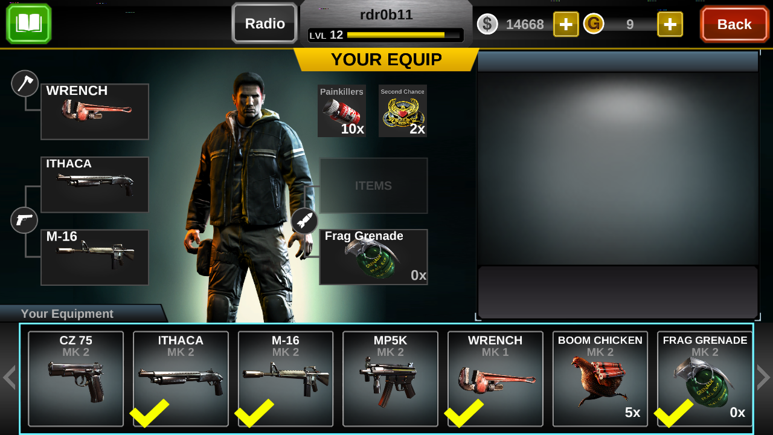

Map

**Musical Scores and Sound Effects**

Music Inspirations

Lemmings (Amiga) Soundtrack, Empire of the Ants OST - Formicidae March Soundtrack

Voices

Oddworld: Abe’s Oddysee, Worms Armageddon, Minions

^ Cute, cartoony voices

Can buy extra voice packs.

YouTube clips - “Wimpy Goat” and “Cameramen have feelings”.

**Single Player Game**

Story

Relationship with Anturions Queen - Good - Anturions workers will be more efficient, unlock upgrades, etc.

If relationship with Anturion Queen - Bad - Anturions workers will work less and less with you, until to the point where none of Anturions workers will want to work and then you have to go back to previous levels to build up relation again.

Hours of Game-play

Depends on how efficient the player is, level replay and purchasing more chapters.

Victory Conditions

Water source is connected to human centre.

A set RP is needed to pass the level. Levels can be replayed to earn more RP.

**Character Rendering**

All 2D sprite based. Cut scenes will be cartoon drawings.